Welcome to Eastman Therapy Centre!

Thank you for choosing us as your therapy provider; we have been in the business of providing quality health care solutions for 20 years now. Our goal at Eastman Therapy is to provide customized, professional treatment plans for every individual that enters our doors.

This is your introduction package to the clinic: we ask that you read the entire write-up and fill out all the information in full. If you have any questions or concerns, please feel free to ask our friendly administrative staff.

- Please be on time for your appointments. If you are going to be late, all we ask for is a phone call prior to the appointment. This will help us to adjust our schedule accordingly. Being late by more than 15 minutes may require your appointment to be rescheduled.
- Cancellations require 24-hour notice. We understand life happens and we will try to be as understanding as possible. If cancellations without proper notice occur, a $30 fee will be added to your next appointment.
- A physician’s referral is not required for you to attend our clinic, but it may be required for your insurance coverage. It is your responsibility to determine the details of your insurance coverage. If coverage is denied, you are responsible for any costs.
- Manitoba Health does not cover any of the costs of treatment.
- Payments must be made in full after each visit.
- Please inquire about our direct billing to private insurance companies. We do direct bill to MPI and WCB for claims.
- It is your responsibility to provide us with your MPI or WCB claim number. You must pay for MPI and WCB claims only if the claim is denied.
- There may be discomfort experienced throughout the therapy process. Everyone’s body reacts differently to treatment and occasionally people will feel sore and tender. Inform your therapist if you experience discomfort.

Eastman Therapy is a teaching facility; occasionally we have university interns working with our therapists. All confidentiality protocols will still be followed, and the intern will be under full supervision of a registered therapist. If you do not feel comfortable working with an intern, please bring it to the attention of your therapist.

Thank you again for choosing us,

Eastman Therapy Centre

Client name (print): ___________________________ Date: __________________________

Client/guardian signature: ______________________

PLEASE FLIP OVER

David Blatz CAT(C), BPE, CFC
Ashley Gerbrandt CAT(C), BKIN, BSc
Jodi Schultz CAT(C), BKIN
Eric Larson BMR – PT, BSc
Feel Better Move Better Be Better
P: (204) 326-5150 F: (204) 346-9734 Unit 6 – 380 Stonebridge Crossing
Steinbach, MB R5G 2R1

Patient Information

Name: _________________________________________ Date of Birth (D/M/Y): __________________________
Mailing address: _________________________________
City: ______________________________________ Phone #: ____________________________________
Postal Code: ____________________________________ E-mail: _____________________________________
Preferred contact method: 󠆲
TEXT PHONE CALL E-MAIL (email address will be used for appointment reminders and to receive receipts).
Employer: Occupation:
Family/Referring physician:
How many days a week do you get 30 minutes of Exercise? (please circle one)
0 1 2 3 4 5 6 7
Emergency contact name and #: ___________________________________________________________________
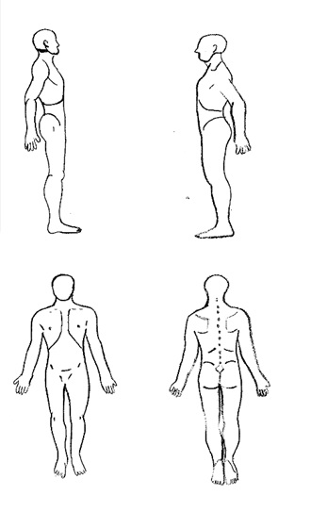
Injury Information
Each appointment is based on one injury claim per session.
Injured body area: ___________________________________
On the body chart to the right, please circle the injured area:

Approx. date of injury: ________________________________
Is this a recurring injury/issue? YES NO
Others who have treated this condition: ___________________
___________________________________________________
Current medications: _________________________________
___________________________________________________
___________________________________________________
Please describe any past injuries or medical conditions:
___________________________________________________
___________________________________________________

Claim Information
Fill this section out ONLY if you have an open/pending MPI or WCB claim
WCB Claim #: _______________________________ MPI Claim #: _________________________________
Have you previously attended another clinic or facility for treatment for this injury: YES NO

